 PROVIDENCE PRESBYTERIAN CHURCH

April 27, 2025

2nd Sunday of Easter

WELCOME AND ANNOUNCEMENTS

PRELUDE *“Beautiful Savior”*  arr. Cherwien

*CALL TO WORSHIP

Peace be with you! Why are you frightened, and why do doubts arise in your hearts? Jesus says, “Look at my hands and my feet; see that it is I myself. Touch me and see, for a ghost does not have flesh and bones as you see that I have.”

**Jesus is risen! Alleluia! Because he lives, we too shall live forever!**

**Let us rejoice and be glad!**

Let us worship God!

*OPENING PRAYER

*HYMN  *“Joyful, Joyful, We Adore Thee”* # 611

PRAYER OF CONFESSION

**Gracious God, we put our faith and trust in you, who made us in your image. We live, we love, we laugh, because we are like you. We believe in Jesus Christ, the Son of God, our Lord and Savior. He had the last laugh on the devil when He rose from the dead. We believe in the Holy Spirit, co-equal and co-eternal with the Father and the Son. Our counselor, our guide, our motivator, our joy! Forgive us, Lord, when we take ourselves too seriously, when we don't claim the joy that is rightfully ours as your children, when we forget that you will have the last laugh in this world. Restore to us the joy of our salvation, through Jesus Christ our Lord, Amen.**

ASSURANCE OF PARDON

*GLORIA PATRI # 583

ANTHEM *“”*

CHILDREN’S CHAT

PRAYER OF ILLUMINATION

GOSPEL READING Luke 24: 13-35

GOSPEL READING Luke 24: 36-49

SERMON “A Walk to Remember”

*HYMN *“I Danced in the Morning”* # 157

*APOSTLES’ CREED

**I believe in God, the Father Almighty, creator of heaven and earth. I believe in Jesus Christ, his only Son, our Lord, who was conceived by the Holy Spirit, born of the Virgin Mary, suffered under Pontius Pilate, was crucified, died, and was buried; he descended to the dead. On the third day he rose again; he ascended into heaven, is seated at the right hand of the Father, and will come again to judge the living and the dead. I believe in the Holy Spirit, the holy catholic church, the communion of saints, the forgiveness of sins, the resurrection of the body, and the life everlasting. Amen.**

Our offerings are a sign of gratitude. Let us join together and sing our praise to God from whom all blessings flow.

*DOXOLOGY “*Praise God, from Whom All Blessings Flow*” # 608

PRAYERS OF THE PEOPLE AND THE LORD’S PRAYER

**Our Father in heaven, hallowed be your name, your kingdom come, your will be done, on earth as in heaven. Give us today our daily bread. Forgive us our sins as we forgive those who sin against us. Save us from the time of trial and deliver us from evil. For the kingdom, the power, and the glory are yours now and forever. Amen.**

*HYMN *“Thine is the Glory”*  # 238

*CHARGE AND BLESSING

*POSTLUDE

* Please stand if you are able.

Prayer: Kasten Mollica

Liturgist: Sue Payne Nursery: Debbie Mallow

Today 10:15 AM Worship

WEDNESDAY 6:30 PM Choir

THURSDAY 11:30 AM Bible Study

SATURDAY 8:00 AM Yard Sale

SUNDAY 9:00 AM Sunday School

10:15 AM Worship

Yard Sale May 3 8 a.m.-12 p.m. (benefits Camp Krislund Scholarships)

 Hopefully you’ve remembered us while doing your spring cleaning.  We will accept donations, set up and price items Monday, April 28-Thursday, May 1 from 9am to 12 noon.  Please, no clothing or stuffed animals.  If these donation times do not suit; please talk with a member of the Outreach Team.  Assistance from our church family is very welcome for set up, pricing and the day of the event.

Please remember to check the poster on the bulletin board for items needed for **CC's Boutique**.

National Day of Prayer – Thursday, May 1. The church will be open from 10 a.m. – 2 p.m.

On May 18, the youth will be enjoying a Curve game together. Please sign up by May 11 if you are interested.

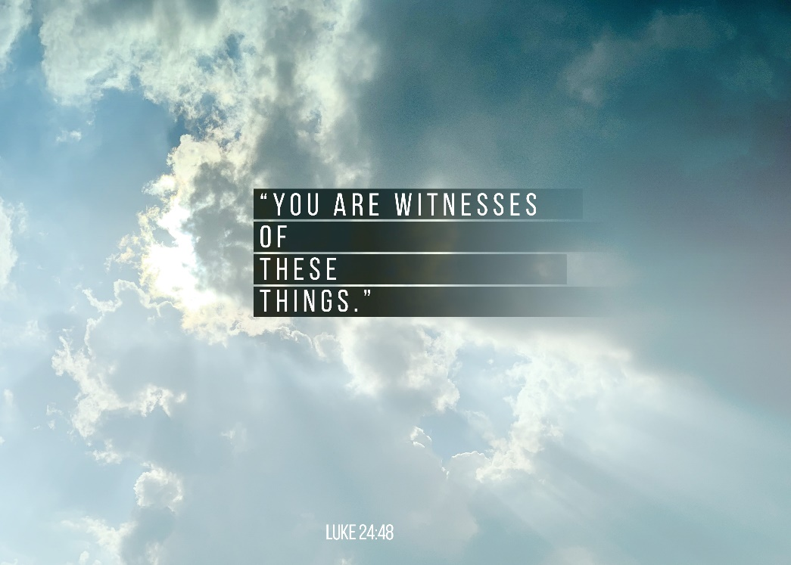



2401 Broad Avenue

Altoona, PA 16601

(814) 577-4269

Rev. Dr. Hilary Livingston

**Website:** [**www.providencepc-altoona.org**](http://www.providencepc-altoona.org)